[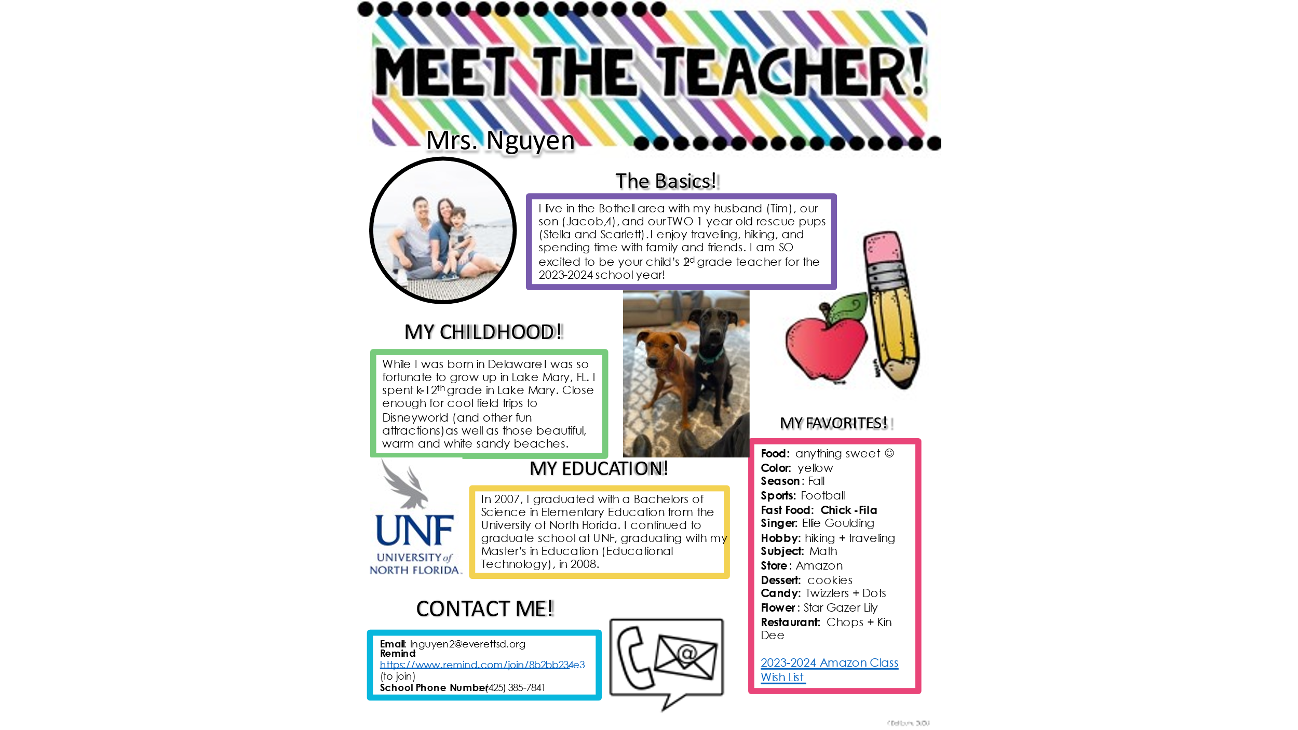](https://www.amazon.com/hz/wishlist/dl/invite/iJ4lJwh?ref_=wl_share)